1. **Post**

URL: <http://localhost:8080/Pet>

Request Body:

{

"id": "002",

"name": "tommy"

}

Output:

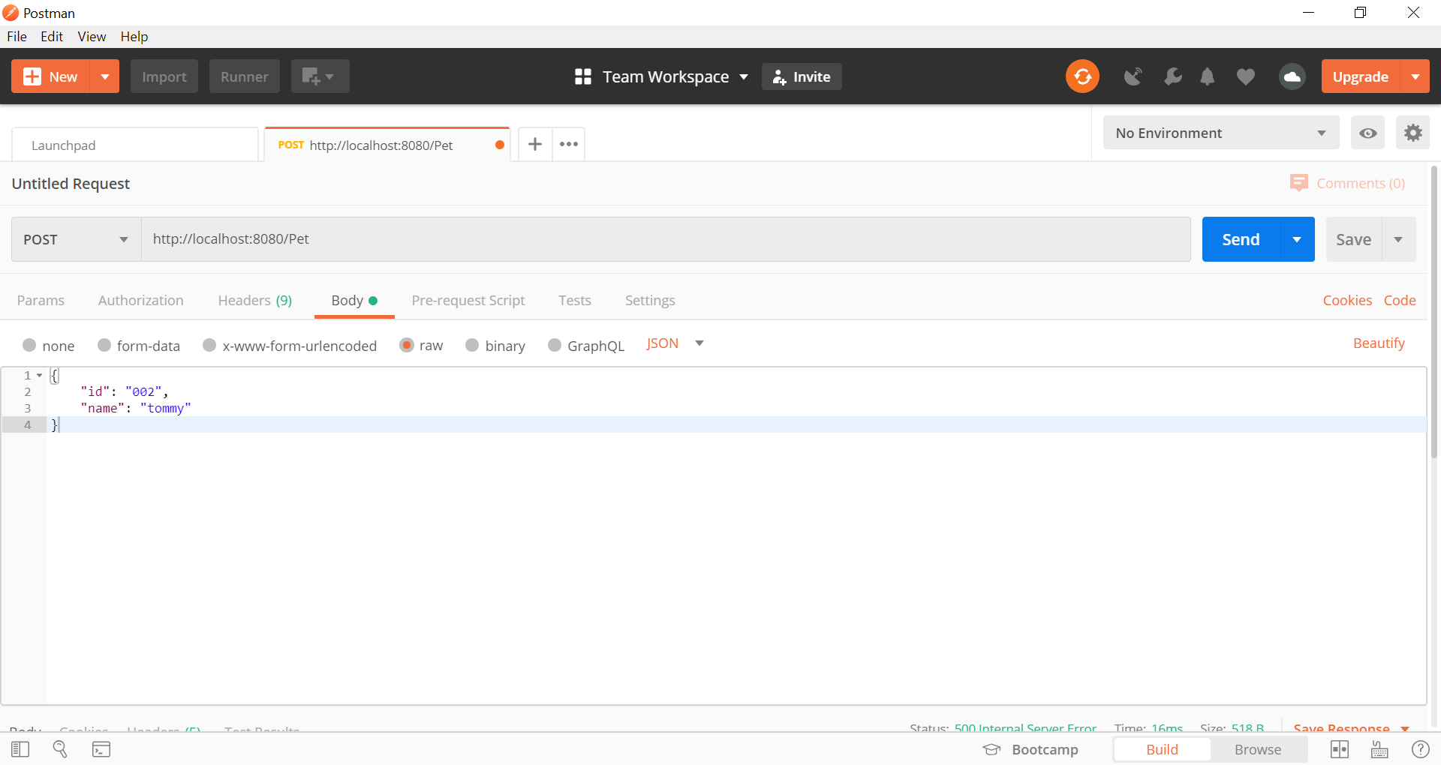

1. **Get**
   1. Get all pets

URL: <http://localhost:8080/Pet>

Request Body: none

Output:

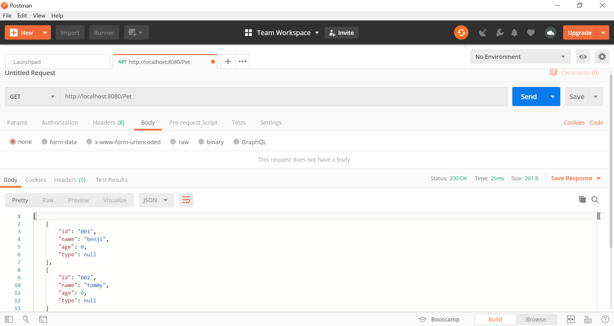

* 1. Get pet by id

URL: <http://localhost:8080/Pet/001>

Request Body: none

Output:

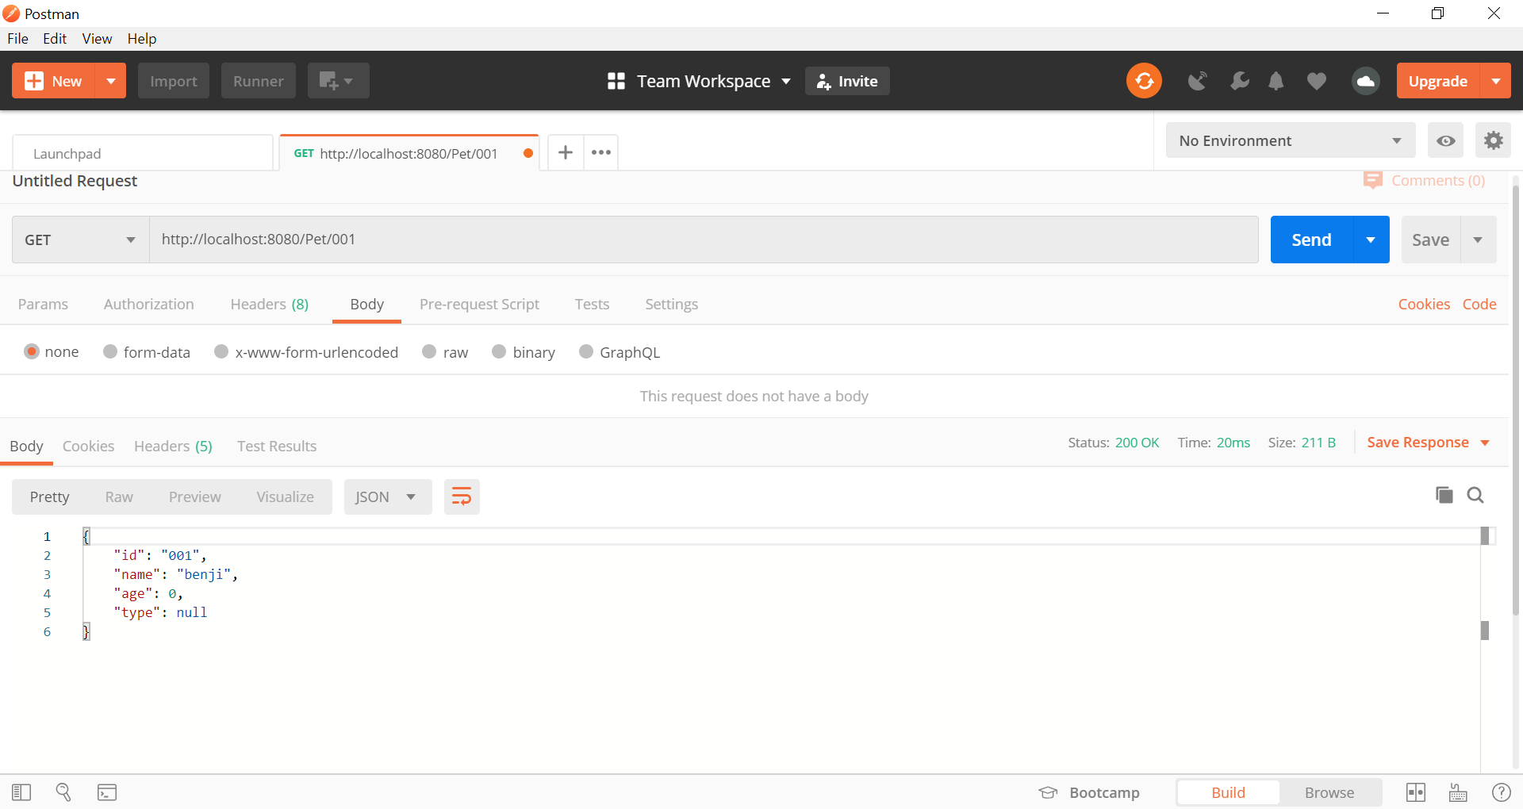

1. **Put**

URL: <http://localhost:8080/Pet/001>

Request body:

{

"id": "001",

"name": "benji",

"age": 12,

"type":"dog"

}

Output:

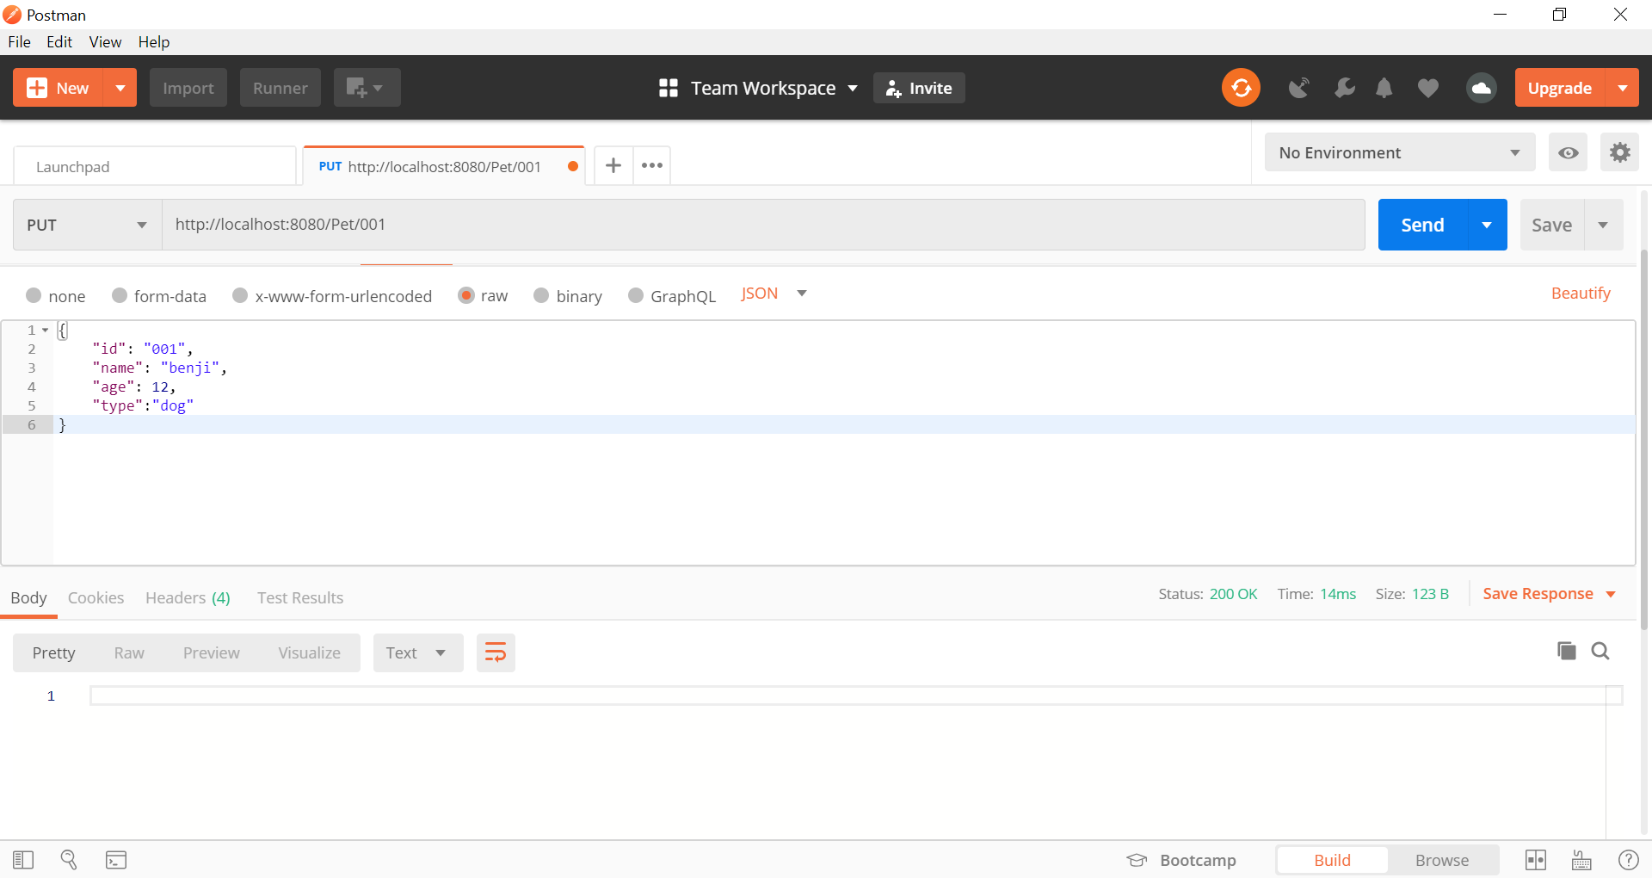

Proof of concept:

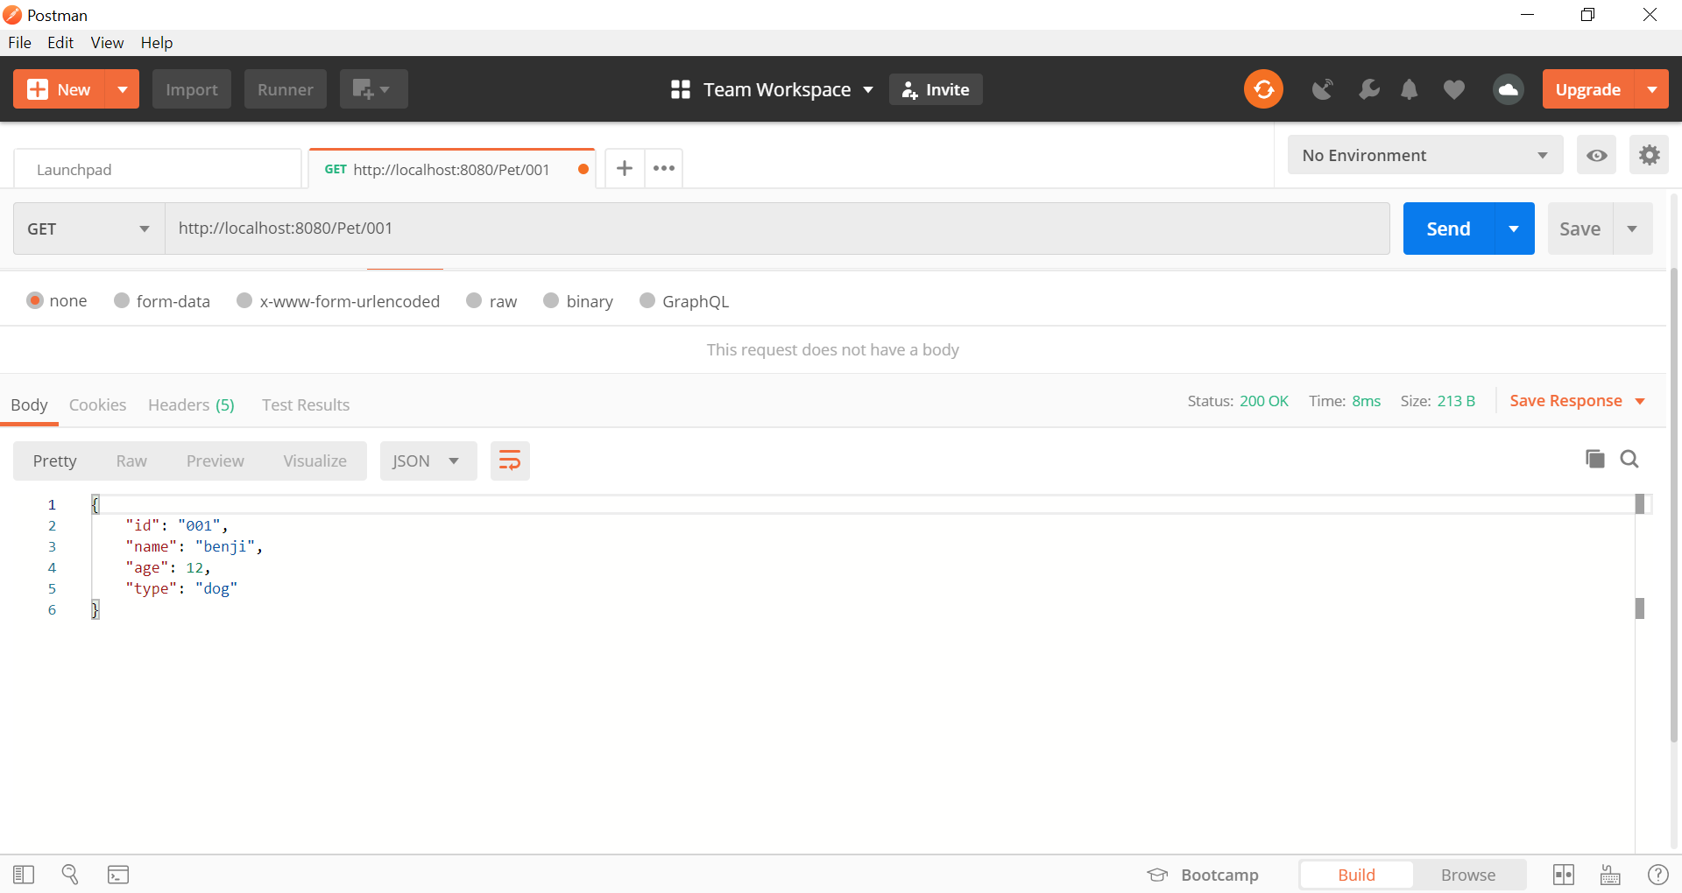

1. **Delete**

URL: <http://localhost:8080/Pet/001>

Request body: none

Output:

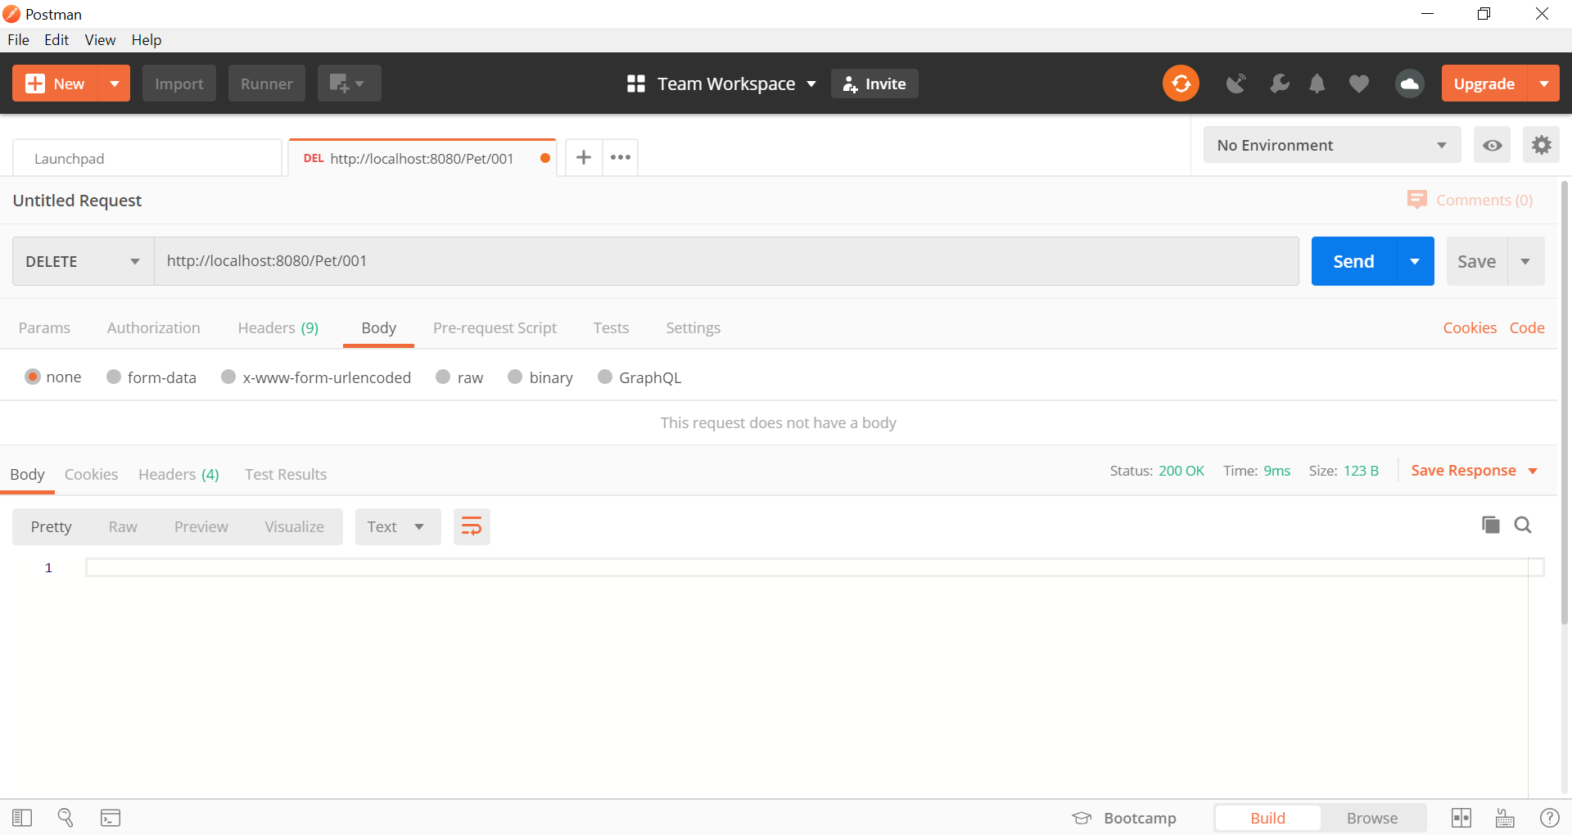

Proof of concept:

